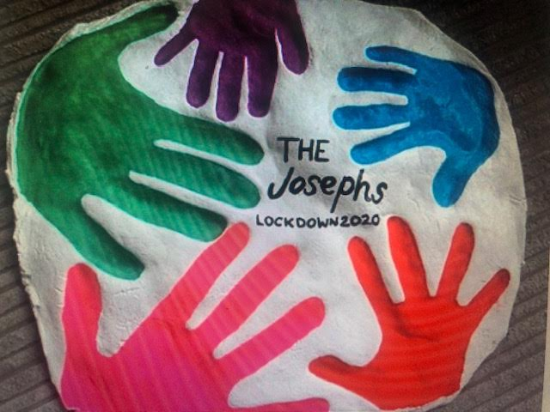
Ingredients for this size:
500 grams of plain flour (that’s roughly 2 1/8 cups)
250 grams salt (that’s roughly 1 cup – maybe just a bit over 1 cup)
250 milliliters of water You can add slightly more water if necessary. (That is roughly 1 cup, maybe just a bit more.
Instructions
▶️Mix the flour and salt then add the water
▶️Mix into a dough
▶️Roll out onto flat surface into desired shape about 1-1.5cm thick (remember to sprinkle some flour down to prevent sticking)
▶️Place on a baking tray
▶️Make hand imprints (as deep/clear as possible)
▶️Place in the oven on the -lowest heat possible- and leave for 3-4 hours or until completely solid top and bottom. (Alternatively you can leave to air dry for a couple of days in a cool dry place- this is the best option if you only have self-rising flour)
▶️After it is hardened, paint with your choice of paints/colors. (I used acrylic paints)
▶️Seal with any kind of varnish or sealer to preserve it. Varnish, modpodge, PVA, etc. If you don’t have paints/varnish, then make it and paint it at a later date. I used acrylic paints (although you can use whatever you have 😊) and you paint it after it has been in the oven. Check that the bottom is rock solid before you take it out and make sure you have it on the ovens lowest heat or it will burn instead.

