Name: ___________________________ Page 1 of 2
Planet Riddles
1. I'm the planet that everyone calls “Red,” But really my soil is rust-colored instead. Look up and you may spot me in the sky, I'm the orange-colored dot, way up high.
Which planet am I? __________________________________
2. With over 63 moons, you might say I have a lot. Look with a telescope to see my big, red spot. The spot is a wind storm, swirling around.
High in the night sky is where I can be found.
Which planet am I? __________________________________
3. I'm blue and green and a little brown. I'm a small planet with life all around. They call me the third rock from the sun. I don't have many moons - just one.
Which planet am I? __________________________________
4. No matter how hard you look, you'll never find me,
Unless you have a telescope to help you see.
I was once called a planet, but not any more.
Now I'm just a “Dwarf Planet,” but too important to ignore.
Which planet am I? __________________________________
5. Look very close to the sun and you'll spot,
A tiny, cratered planet that's very hot.
I have no moons but I orbit the sun very fast. Can you guess my name at last?
Which planet am I? __________________________________

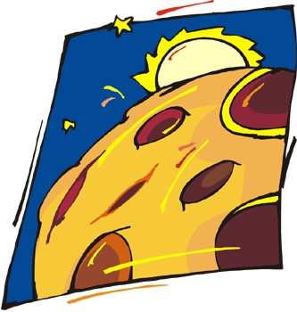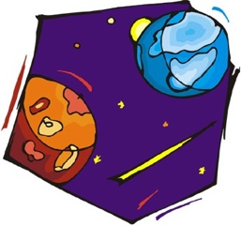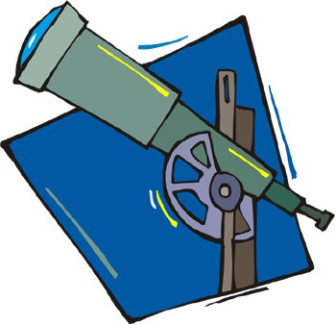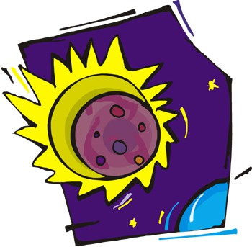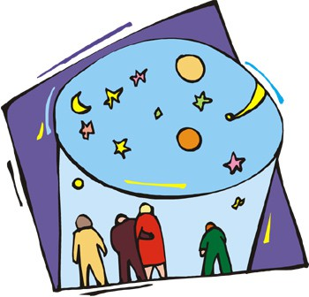

Name: ___________________________ Page 2 of 2
Planet Riddles
6. I'm yellow and cloudy and super hot. Look low in the sky, I'm easy to spot. People call me the “Evening Star” From planet Earth, I'm not very far.
Which planet am I? __________________________________
7. Named for the Roman god of the Sea, Look past Saturn and Uranus for me.
I had a black spot that was a huge storm. Now it's all gone, but I'll still never be warm.
Which planet am I? __________________________________
8. I'm a giant gas planet out in space,
There are bands or stripes all over my face. When it comes to size, I'm number two,
I have bright rings. That's an easy clue.
Which planet am I? __________________________________
9. A gas planet that's off in the distance,
Only recently they found my rings in existence. I'm blue and cold and far away,
People say I'm funny because I spin sideways.
Which planet am I? __________________________________
